Assignment-4

|  |  |
| --- | --- |
| Assignment Date | 1 October 2022 |
| Student Name | Mr.k.vignesh |
| Student Roll Number | AC19UCS135 |
| Maximum Marks | 2 Marks |

# **Question-1:**

# Write code and connections in wokwi for ultrasonic sensor. Whenever distance is less than 100 cms send "alert" to ibm cloud and display in device recent events.

**Solution :**

#include <WiFi.h> #include <PubSubClient.h>

void callback(char* subscribetopic,byte* payload, unsigned int payloadLength); #define ORG "fdd82r"

#define DEVICE_TYPE "Pi" #define DEVICE_ID "123"

#define TOKEN "12345678"

String data3;

char server[]= ORG ".messaging.internetofthings.ibmcloud.com"; char publishTopic[]="iot-2/evt/distance/fmt/json";

char subscribeTopic[]="iot-2/cmd/test/fmt/String"; char authMethod[]="use-token-auth";

char token[]=TOKEN;

char clientID[]="d:"ORG":"DEVICE_TYPE":"DEVICE_ID;

WiFiClient wifiClient;

PubSubClient client(server,1883,callback,wifiClient);

#define ECHO_PIN 2

#define TRIG_PIN 4

#define led 5

void setup() {

// put your setup code here, to run once: Serial.begin(115200);

pinMode(led, OUTPUT); pinMode(TRIG_PIN, OUTPUT); pinMode(ECHO_PIN, INPUT);

wificonnect(); mqttconnect();

}

float readDistanceCM() {

digitalWrite(TRIG_PIN, LOW); delayMicroseconds(2); digitalWrite(TRIG_PIN, HIGH); delayMicroseconds(10); digitalWrite(TRIG_PIN, LOW); int duration=random(1,200);

//Serial.println(duration);

//duration = pulseIn(ECHO_PIN, HIGH); return duration ;

//Serial.println(duration);

}

void loop() {

float distance = readDistanceCM();

//Serial.println(distance);

bool isNearby = distance < 100; digitalWrite(led, isNearby);

Serial.print("Measured distance: "); Serial.println(distance); if(distance<100){ PublishData2(distance);

}else{ PublishData1(distance);

}

//PublishData(distance); delay(1000); if(!client.loop()){ mqttconnect();

}

//delay(2000);

}

void PublishData1(float dist){ mqttconnect();

String payload= "{\"distance\":"; payload += dist;

payload+="}";

Serial.print("Sending payload:"); Serial.println(payload);

if(client.publish(publishTopic,(char*)payload.c_str())){ Serial.println("publish ok");

} else{

Serial.println("publish failed");

}

}

void PublishData2(float dist){ mqttconnect();

String payload= "{\"ALERT\":"; payload += dist;

payload+="}";

Serial.print("Sending payload:"); Serial.println(payload);

if(client.publish(publishTopic,(char*)payload.c_str())){ Serial.println("publish ok");

} else{

Serial.println("publish failed");

}

}

void mqttconnect(){ if(!client.connected()){ Serial.print("Reconnecting to "); Serial.println(server);

while(!!!client.connect(clientID, authMethod, token)){ Serial.print(".");

delay(500);

}

initManagedDevice(); Serial.println();

}

}

void wificonnect(){ Serial.println(); Serial.print("Connecting to");

WiFi.begin("Wokwi-GUEST","",6); while(WiFi.status()!=WL_CONNECTED){ delay(500);

Serial.print(".");

}

Serial.println("");

Serial.println("WIFI CONNECTED"); Serial.println("IP address:");

Serial.println(WiFi.localIP());

}

void initManagedDevice(){ if(client.subscribe(subscribeTopic)){ Serial.println((subscribeTopic)); Serial.println("subscribe to cmd ok");

}else{

Serial.println("subscribe to cmd failed");

}

}

void callback(char* subscribeTopic, byte* payload, unsigned int payloadLength){ Serial.print("callback invoked for topic:");

Serial.println(subscribeTopic); for(int i=0; i<payloadLength; i++){ data3 += (char)payload[i];

}

Serial.println("data:"+ data3); if(data3=="lighton"){ Serial.println(data3); digitalWrite(led,HIGH);

}else{ Serial.println(data3); digitalWrite(led,LOW);

}

data3="";

}

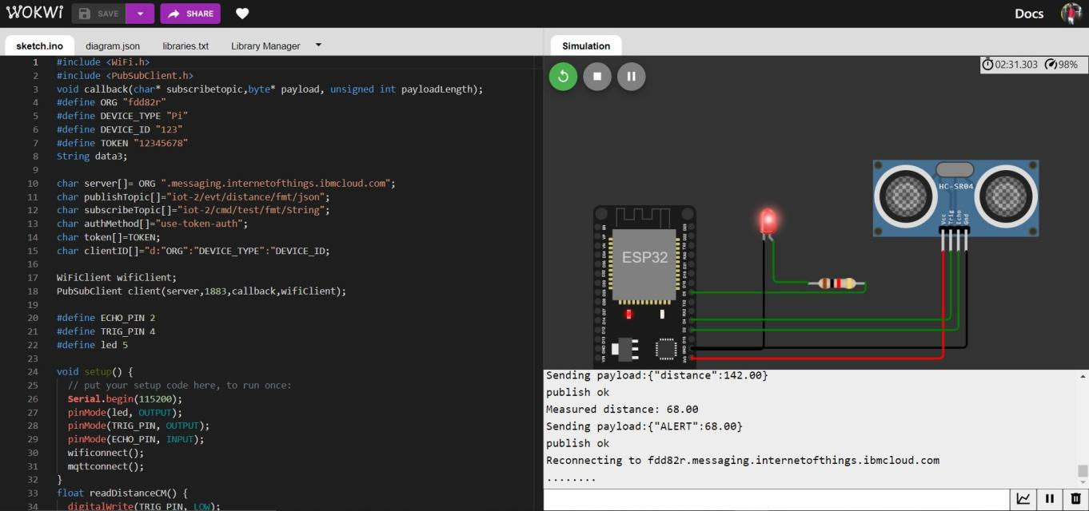

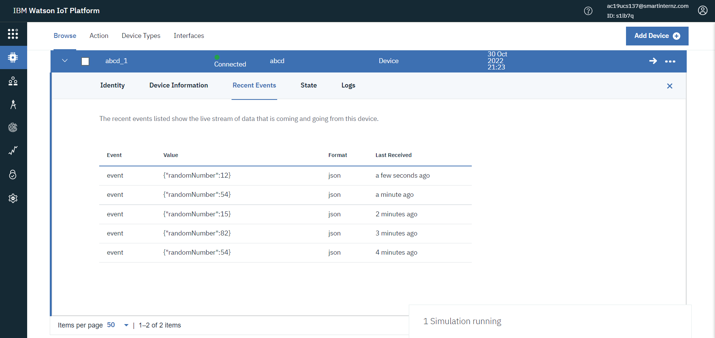

REFERENCE: <https://wokwi.com/projects/347098827192271442>